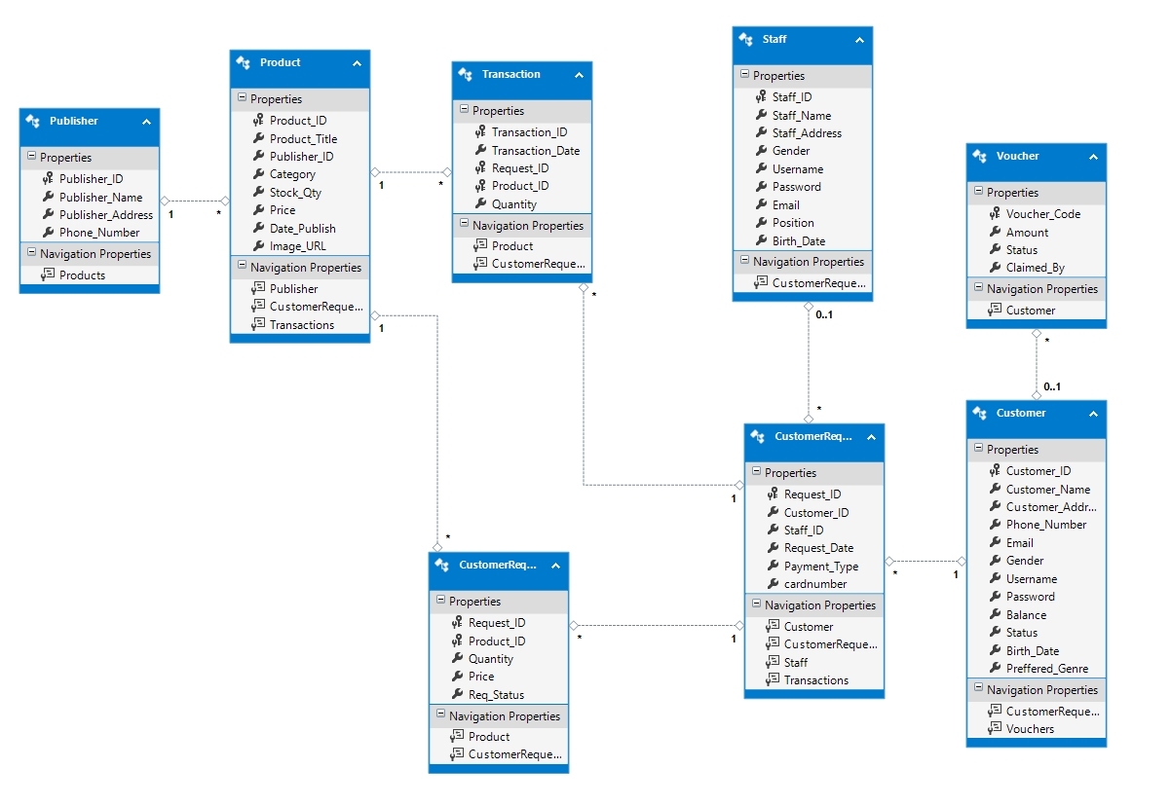

**Logical ERD**

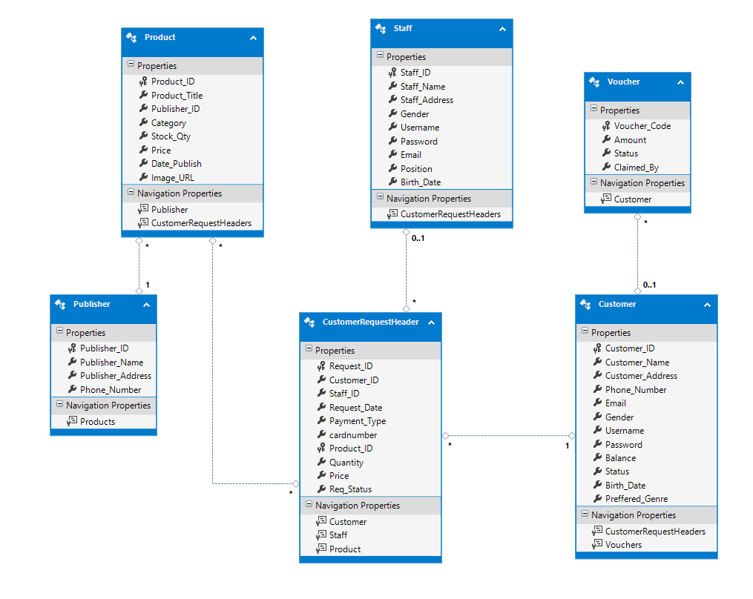

**Conceptual ERD**

**Data Dictionary**

Database

|  |  |
| --- | --- |
| **Name** | **Description** |
| Publisher.Publisher_ID | Primary key of Publisher table, used to save the Publisher ID, format : PBL[0-9] [0-9] [0-9] [0-9] [0-9] |
| Publisher.Publisher_Name | Used to save the Publisher Name, required (not null) |
| Publisher.Publisher_Addres | Used to save the Publisher Address, required (not null) |
| Publisher.Phone_Number | Used to save the Publisher Phone, required (not null) |
| Product.Product_ID | Primary key of Product table, used to save the Book ID, format : PRD[0-9] [0-9] [0-9] [0-9] [0-9] |
| Product.Product_Title | Used to save the Book Title, required (not null) |
| Product.Publisher_ID | Foreign key of Publisher.Publisher_ID |
| Product.Category | Used to save the Book Category, required (not null) |
| Product.Stock_Qty | Used to save the Book Stock, required (not null) |
| Product.Price | Used to save the Book Price, required (not null) |
| Product.Date_Publish | Used to save the Book Date Publish, required (not null) |
| Product.Image_URL | Used to save the Book Cover Picture, can be null |
| Transaction.Transaction_ID | Primary key of Transaction table, used to save Transaction ID, format : TR[0-9] [0-9] [0-9] [0-9] [0-9] |
| Transaction.Transaction_Date | Used to save the transaction date |
| Transaction.Request_ID | Foreign key of CustomerRequestHeader.Request_ID |
| Transaction.Product_ID | Foreign key of Product.Product_ID |
| Transaction.Quantity | Used to save the quantity sent in the transaction |
| Staff.Staff_ID | Primary key of staff table, used to save the ID of each staff, format : STF[0-9] [0-9] [0-9] |
| Staff.Staff_Name | Used to save the staff name, required (not null) |
| Staff.Staff_Address | Used to save the staff address, required (not null) |
| Staff.Gender | Used to save the staff gender, required (not null) check male or female |
| Staff.Username | Used to save the staff username, required (not null) max character is 20, must be unique |
| Staff.Password | Used to save the staff password, required (not null) max character is 25 |
| Staff.Email | Used to save the staff email, required (not null), must be unique |
| Staff.Position | Used to save the staff position, required (not null) |
| Staff.Birth_Date | Used to save the staff birthdate, required (not null) |
| Customer.Customer_ID | Primary key of Customer table, used to save the ID of customer, format : CST[0-9] [0-9] [0-9] [0-9] [0-9] |
| Customer.Customer_Name | Used to save the customer name, required (not null) |
| Customer.Customer_Address | Used to save the customer address, required (not null) |
| Customer.Phone_Number | Used to save the customer phone number, required (not null) must be unique |
| Customer.Email | Used to save the customer email, required (not null) must be unique |
| Customer.Gender | Used to save the customer gender, required (not null) check either male or female |
| Customer.Username | Used to save the customer username, required (not null), max character is 20, must be unique |
| Customer.Password | Used to save the customer password, required (not null), max character is 25 |
| Customer.Balance | Used to save the customer balance, can be null (starting is 0) |
| Customer.Status | Used to save the customer status, required (not null), to know whether the account is verified or not |
| Customer.Birth_Date | Used to save the customer birth date, required (not null) |
| Customer.Preffered_Genre | Used to save the customer favorite genre, required (not null) |
| Voucher.Voucher_Code | Primary key of voucher table, to save the code of the voucher length is 15 (alphanumeric) |
| Voucher.Amount | Used to save the amount of the voucher, required (not null) |
| Voucher.Status | Used to save the status of voucher (claimed or not claimed) |
| Voucher.Claimed_By | Foreign key of Customer.Customer_ID, can be null |
| CustomerRequestHeader.Request_ID | Primary key CustomerRequestHeader, format : RQ[0-9] [0-9] [0-9] [0-9] [0-9] |
| CustomerRequestHeader.Customer_ID | Foreign key of Customer.Customer_ID |
| CustomerRequestHeader.Staff_ID | Foreign key of Staff.Staff_ID |
| CustomerRequestHeader.Request_Date | Used to save the request date of the customer, required (not null) |
| CustomerRequestHeader.Payment_Type | Used to save the payment type of customer, required (not null) |
| CustomerRequestHeader.cardnumber | Used to save the card number of customer (if payment type is credit card) |
| CustomerRequestDetail.Request_ID | Foreign Key of CustomerRequestHeader.Request_ID and Primary Key of CustomerRequestDetail |
| CustomerRequestDetail.Product_ID | Foreign Key of Product.Product_ID and Primary Key of CustomerRequestDetail |
| CustomerRequestDetail.Quantity | Used to save the quantity left to be sent, required (not null) |
| CustomerRequestDetail.Price | Used to save the current price of order, required (not null) |
| CustomerRequestDetail.Req_Status | Used to save the status of customer’s request, required (not null) |

C#

|  |  |
| --- | --- |
| **Name** | **Description** |
|  |  |
|  |  |
|  |  |
|  |  |
|  |  |
|  |  |
|  |  |